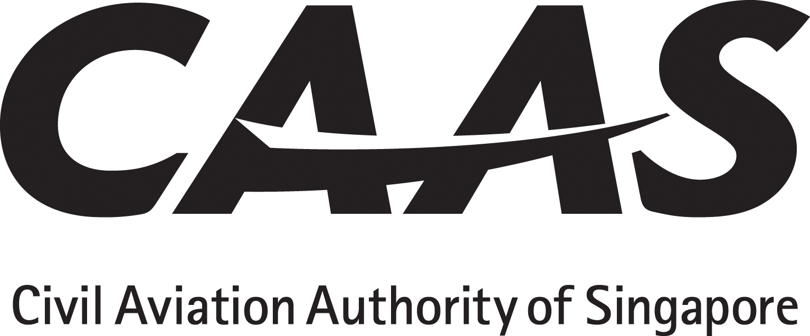

CAAS MAINTENANCE ORGANISATION EXPOSITION AND SUPPLEMENT CROSS REFERENCE AGAINST SAR-145 REQUIREMENTS CHECKLIST

Name of SAR-145 Approved Maintenance Organisation: | Approval No: AWI /
Amendment Status/ Date of the SAR-145 Requirements:
Reason for Review:

SAR-145 Paragraphs | CAAS or NAA MOE |  | CAAS Supplement Section | Remarks
 | Chapter | Paragraph
SAR-145.1 General
(a) | For organisation’s info
(b) | For organisation’s info
(c) | For organisation’s info
(d) | For organisation’s info
(e) | For organisation’s info
(f)(1) | For organisation’s info
(f)(2) | For organisation’s info
(g) | For organisation’s info |  |  | Reserved
(h) | For organisation’s info
(i) | For organisation’s info
SAR-145.3 Effectivity
(a) | For organisation’s info
(b) | For organisation’s info
SAR-145.5 Definitions
(a) | For organisation’s info
SAR-145.10 Applicability
(a)(1) | For organisation’s info
(a)(2) | For organisation’s info
(b) | For organisation’s info
(c) | For organisation’s info
(d) | For organisation’s info
SAR-145.15 Application and Issue
(a) | For organisation’s info
SAR-145.20 Extent of Approval
SAR-145.21 Display of Certificate
SAR-145.25 Facility Requirements
(a)
(b)
SAR-145 Paragraphs | CAAS or NAA MOE |  | CAAS Supplement Section | Remarks
 | Chapter | Paragraph
(c)
(d)
SAR-145.30 Personnel Requirements
(a)
(b)
(c)
(d)
(e)
(ea)
(eb)
(ec)
(ed)
(ee)
(f)(1)
(f)(2)
(f)(3)
(f)(4)
(f)(5)
(g)(1)
(g)(2)
(g)(3)
SAR-145.35 Certifying Staff
(a)
(b)
(c)
(d)
(e)
(f)
(g)
(h)
(i)
(j)
SAR-145.40 Equipment, Tools and Material
(a)
(b)
SAR-145.45 Maintenance Data
(a)
(b)(1) | For organisation’s info
(b)(2) | For organisation’s info
(b)(3) | For organisation’s info
(b)(4) | For organisation’s info
(b)(5) | For organisation’s info
(b)(6) | For organisation’s info
(c)
SAR-145 Paragraphs | CAAS or NAA MOE |  | CAAS Supplement Section | Remarks
 | Chapter | Paragraph
(d)
(e)
(e)(1)
(f)
(g)
SAR-145.50 Certificate of Maintenance
(a)
(b)
(c) | For organisation’s info |  |  | Reserved
(d)
(e)
(f)
SAR-145.55 Maintenance Records
(a)
(b)
(c)
SAR-145.60 Reporting of Un-airworthy Conditions
(a)
(b)
(c)
(d)
SAR-145.64 Safety Management System
(a)
(b)
SAR-145.65 Maintenance Procedures and Quality Systems
(a)
(b)
(c)(1)
(c)(2)
SAR-145.70 Maintenance Organisation Exposition
(a)(1) |  |  |  | Clauses SAR-145.70(a)(1) to SAR-145.70(a)(11) are required to be in the CAAS MOE or Supplement
(a)(2)
(a)(3)
(a)(4)
(a)(5)
(a)(6)
(a)(7)
(a)(8)
(a)(9)
(a)(10)
(a)(11)
(a)(12)
(a)(13)
(a)(14)
SAR-145 Paragraphs | CAAS or NAA MOE |  | CAAS Supplement Section | Remarks
 | Chapter | Paragraph
(a)(15)
(a)(16)
(a)(17)
(b)
(c)
(d)
SAR-145.75 Privileges of the Approved Maintenance Organisation
(a)
(b)
(c)
(d)
(e)
SAR-145.80 Limitations of the Approved Maintenance Organisation
(a)
(b)
SAR-145.85 Changes to the Approved Maintenance Organisation
(a)(1)
(a)(2)
(a)(3)
(a)(4)
(a)(5)
(a)(6)
(b) | For organisation’s info
SAR-145.90 Continued Validity of Approval
(a)
(b)
(c)
SAR-145.95 Equivalent Safety Case
(a) | For organisation’s info
(b) | For organisation’s info

Name of Reviewer | Title | Signature | Date

