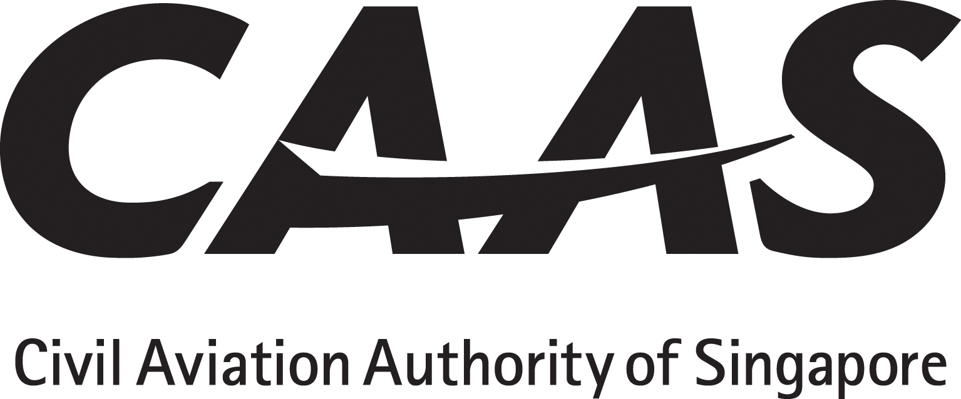

SUBMISSION OF EXTENDED DIVERSION TIME OPERATIONS (EDTO) APPLICATION DOCUMENTS
The applicant will tick (√) the appropriate Yes / No boxes

DOCUMENTS TO BE SUBMITTED WITH LETTER OF APPLICATION
Description of Documents | Completion by applicant | CAAS Use
1. Compliance statement which shows how the requirements in ANR-98 Regulations 41-45 and Third Schedule. | □ Yes □ No
2. Configuration, Maintenance & Procedures (CMP) Document (latest revision). | □ Yes □ No
3. Sections of the AFM or AFM Supplements that document EDTO airworthiness approval. | □ Yes □ No
4. CMP compliance list showing compliance with the titles and numbers of all modifications, addition and changes which were made in order to substantiate the incorporation of the CMP standard in the aeroplane. | □ Yes □ No
5. EDTO Manual. | □ Yes □ No
6. Supplements and revisions to the existing Maintenance Programme and Maintenance Procedures. | □ Yes □ No
7. Flight crew / dispatcher EDTO training programmes and syllabi for initial and recurrent training. | □ Yes □ No

8. Operation manuals and checklists that include EDTO operating practices and procedures:  - Operations Manual Part A,  - Operations Manual Part B,  - Operations Manual Part C,  - Operations Manual Part D,  - Aerodrome Operating Minima,  - FCOM,  - Route Manuals,  - Stand-alone EDTO manual, and  - EDTO charts. | □ Yes □ No  □ Yes □ No  □ Yes □ No  □ Yes □ No  □ Yes □ No  □ Yes □ No  □ Yes □ No  □ Yes □ No  □ Yes □ No
9. Minimum Equipment List (MEL) that include items pertinent to EDTO operations. Refer ANR-98 Third Schedule Para 5. | □ Yes □ No
10. HMI (Human/Machine/Interface) review | □ Yes □ No
11. Qualitative Safety Risk Assessment | □ Yes □ No

