APPLICATION FOR REDUCED VERTICAL SEPARATION MINIMA (RVSM)
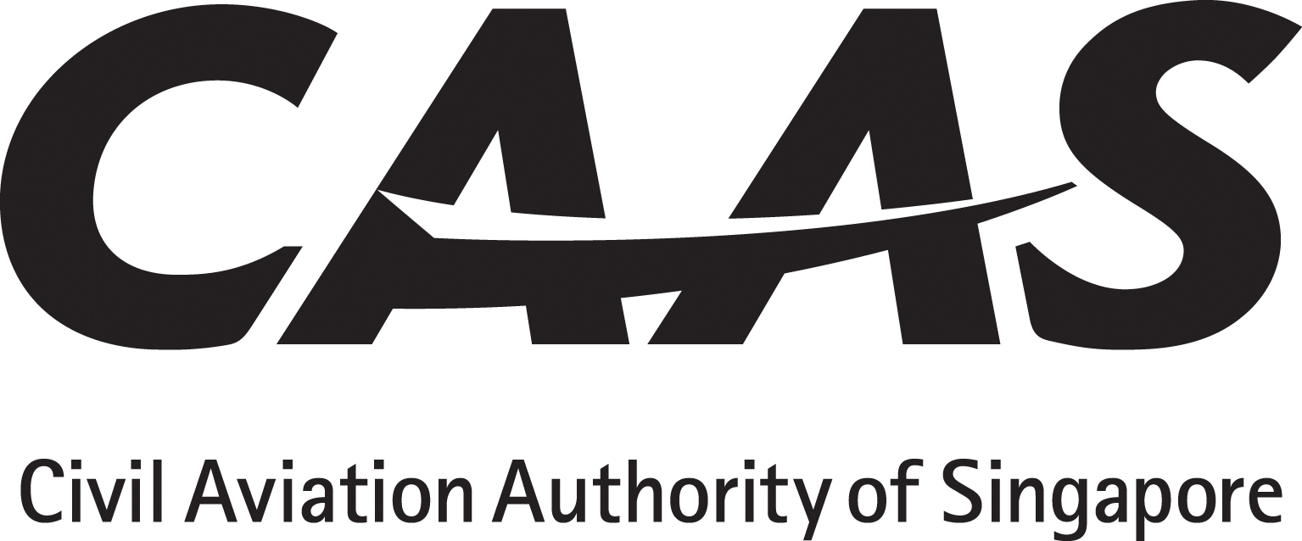
INSTRUCTIONS
1. The operator will tick (√) the appropriate Yes/No boxes, and insert applicable references from the AFM or Ops Manual with sample pages attached as appendix.
2. Operator must obtain and submit manufacturer’s written confirmation with regard to continuing maintenance.
3. Operating policy and procedures, training syllabus and lesson plan must be submitted for approval before commencement of flight crew / dispatcher training.
PARTICULARS
Operator: ___________________________AOC No:___________ Rep’s Name:_________________Position:____________
Aircraft manufacturer,  Model and series |  | Serial number | Registration | Number of altitude measuring systems | Make / model / Type / Series of ACAS / TCAS system |  | Number Make / Model / Type of SSR onboard
AC 98-3-1(0) | Title of Paragraph |  |  |  |  | Operator Compliance Reference |  | CAAS Use
4  4.1  4.2  4.3 | MINIMUM AIRCRAFT SYSTEMS PERFORMANCE SPECIFICATION (MASPS)  The altimetry system performance for operation in RVSM airspace in respect of groups of aeroplanes that are nominally of identical design and build with respect to all details that could influence the accuracy of height-keeping performance capability shall be such that the total vertical error (TVE) for the group of aeroplanes shall have a mean no greater than 25m (80ft) in magnitude.  In addition, the components of TVE shall have the following characteristics:  (a) The mean altimetry system error (ASE) of the group shall not exceed 25m (80ft) in magnitude;  (b) The sum of the absolute value of the mean ASE and of three standard deviations of ASE shall not exceed 75m (245ft); and  (c) The differences between cleared flight level and the indicated pressure altitude actually flown shall be symmetric about a mean of 0m (0ft), with a standard deviation no greater than 13.3m (43.7ft), and in addition, the decrease in the frequency of differences with increasing difference magnitude shall be at least exponential  In respect of aeroplanes for which the characteristics of the airframe and altimetry system fit are unique and so cannot be classified as belonging to a group of aeroplanes encompassed by paragraphs 9.1 and 9.2, the height-keeping performance capability shall be such that the components of the TVE of the aeroplane have the following characteristics:  (a) The ASE of the aeroplane shall not exceed 60 m (200ft) in magnitude under all flight conditions; and  (b) The difference between the cleared flight level and the indicated pressure altitude actually flown shall be symmetric about a mean of 0m (0ft), with a standard deviation no greater than 13.3m (43.7ft), and in addition, the decrease in the frequency of differences with increasing difference magnitude shall be at least exponential.
5  5.1  5.2 | REQUIREMENTS  As required by ANR 98 Paragraph 3 (b) and Division 3 in Part 2, Paragraphs 14 to 19 to qualify for RVSM operational approval, an aeroplane shall be provided with equipment capable of:  (a) Indicating to the flight crew the flight level being flown;  (b) Automatically maintaining a selected flight level;  (c) Providing an alert to the flight crew when a deviation occurs from the selected flight level. The threshold for the alert shall not exceed ±90m (300ft); and  (d) Automatically reporting pressure altitude.  (e) Compliance in the airworthiness aspects of operational approval requirements which must include the RVSM MASPS stated in paragraph 9 above.

6  6.1  6.2 | APPROVAL LIMITATION  RVSM operational approval is aircraft and operator specific; any changes to the identity of the aircraft or operator shall render the RVSM operational approval invalid and the Authority shall be informed of such changes without delay.  Subject to compliance with ICAO Document 7030, Regional Supplementary Procedures, and State AIPs, the RVSM operational approval is valid worldwide.
7  7.1  7.2 | HEIGHT-KEEPING PERFORMANCE MONITORING  Once the operational approval to conduct RVSM operations is granted by the Authority, the operator will complete a MAAR Form F2 (USC Form 2 for EUROCONTROL User Support Cell) for the Authority to submit to the RMA (Regional Monitoring Agency), MAAR for Asia region, for conduct of Aircraft Height-Keeping Performance Monitoring flight.  This Height-Keeping Performance monitoring flight must be conducted within 6 months of the RVSM operational approval.
8  8.1  8.2 | CONTINUING COMPLIANCE OF MASPS  The operator shall set in place a programme to ensure that a minimum of two aeroplanes of each aeroplane-type grouping undergo height-keeping performance monitoring at least once every two years or within intervals of 1000 flight hours per aeroplane, whichever period is the longer.  If the operator’s aeroplane-type grouping consists of a single aeroplane, the height-keeping monitoring of that aeroplane shall be accomplished within the specified period.

9  9.1 | Aircraft Systems - Minimum equipment requirement  2 independent altitude measurement systems each system composed of the following elements:  (a) Static Sources. Cross-coupled static source/system, provided with ice protection if located in areas subject to ice accretion;  (b) Altitude Display. Equipment for measuring static pressure sensed by the static source, converting it to pressure altitude and displaying the pressure altitude to the flight crew;  (c) Altitude Reporting. Equipment for providing a digitally coded signal corresponding to the displayed pressure altitude, for automatic altitude reporting purposes;  (d) Altimetry System Components. The altimetry system should comprise all those elements involved in the process of sampling free stream static pressure and converting it to a pressure altitude output;  (e) Altimetry System Accuracy;  (f) Static Source Error Correction (SSEC);  (g) The equipment fit should provide reference signals for automatic control and alerting at selected altitude; and  (h) Air Data Systems and Configurations with Multiple Static Source Inputs. Many aircraft are produced with air data systems making use of three or more static source inputs, and/or three or more air data computers (ADC). Upon failure of one air data system, a second system must remain fully functional  Note: Compliance to FAA AC 91-58A will demonstrate
9.2 | One Secondary Surveillance Radar (SSR) Altitude Reporting Transponder. If only one is fitted, it should have the capability for switching to obtain input from either altitude measurement system.
9.3 | An Altitude Alert System. The altitude alert system should be capable of operation from either of the two required independent altitude measurement systems.
9.4 | An Automatic Altitude Control System. The automatic altitude control system should be capable of operation from either of the two required independent altitude measurement systems.
9.5 | Automatic Altitude Control System.  As a minimum, a single automatic altitude control system should be installed which is capable of controlling aircraft height within a tolerance band of ±65ft (±20m) about the acquired altitude when the aircraft is operated in straight and level flight under non-turbulent, non-gust conditions.  Where an altitude select/acquire function is provided, the altitude select/acquire control panel must be configured such that an error of no more than ±25ft (±8m) exists between the display selected by the flight crew and the corresponding output to the control system.  Note: Compliance to FAA AC 91-85A is an acceptable means to demonstrate compliance to the aircraft system requirements for RVSM operations
10  10.1  10.2  10.3  10.4  10.5 | CONTINUING AIRWORTHINESS  Maintenance programme approval requirement  Maintenance documents review requirement  Maintenance practices procedures  Maintenance training requirement  Test requirement
11 | MEL Minimum equipment list showing RVSM provisions
□Yes □No | HMI Human / Machine Interface review.
□Yes □No | QSRA Qualitative Safety Risk Assessment

Warning: Notice is given that the operator shall accept full responsibility for all information given in this application form. Any attempt to provide false information will result in rejection of the application and, if already granted, the withdrawal of the Operational Approval. In addition, the operator may render himself liable to prosecution under section 29C(1)(b) of the Air Navigation Act.

I declare to the best of my knowledge and belief that the statements made and the information supplied in this form are complete and correct. I understand that any false representations made by me for the purpose of procuring the Singapore aviation safety instrument is an offence under section 29C(1)(b) of the Air Navigation Act and I may be subject to the penalties stipulated thereunder and any Singapore aviation safety instrument granted pursuant to the application will be revoked.

Signature / Name of person representing the operator:_____________________________________________Date__________________

Signature / Name of FS Officer accepting this form :________________________________________________Date__________________

REFERENCES

Regulatory: (1) ANR 98, Paragraph 3 (b), Division 3 Paragraphs 14 -19.
Compliance: (1) CAAS AC 98-3-1 (2) ICAO Doc 9574 (3) FAA AC 91-85()

