SUBMISSION OF ALL WEATHER OPERATIONS (AWO) DOCUMENTS
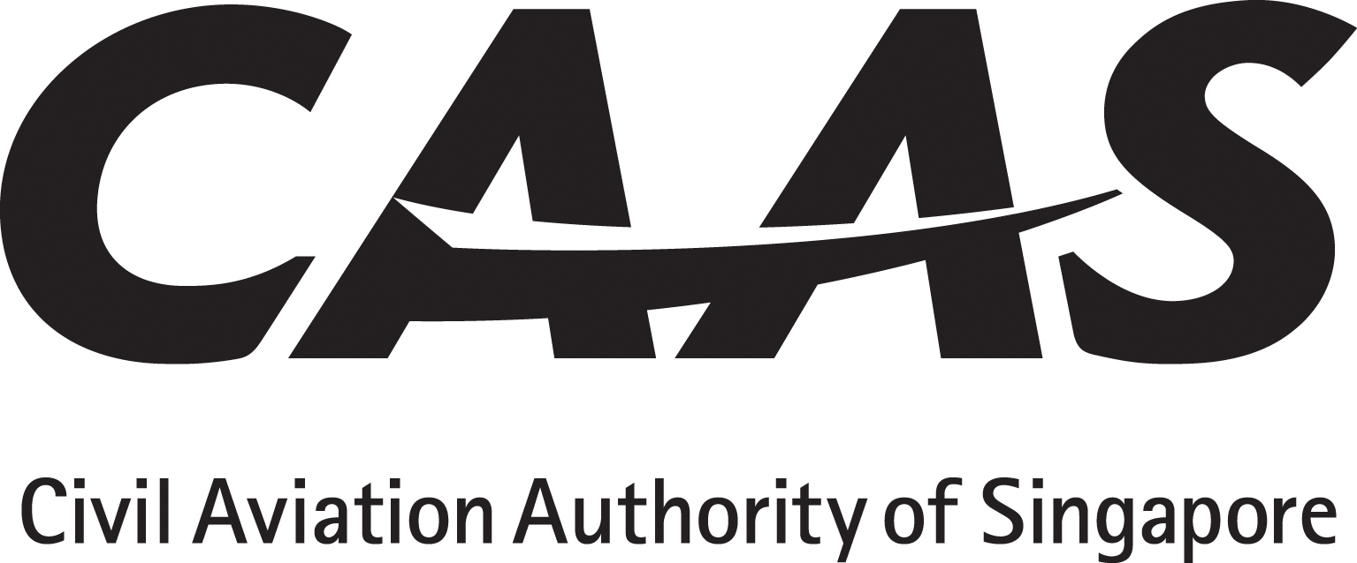

The applicant will tick the appropriate yes/no boxes

DOCUMENTS TO BE SUBMITTED WITH LETTER OF APPLICATION
Description of Documents | By Applicant | Compliance by Applicant
1. Compliance statement which shows how the criteria of  ANR 98 Regulation 4, and applicable Regulations 20 to 33  have been satisfied. | □ yes □ no
2. Sections of the AFM or AFM Supplements that document  AWO airworthiness approval. | □ yes □ no
3. Flight crew AWO training programme and syllabi for  initial and recurrent training. | □ yes □ no
4. Operation manuals and checklists that include AWO  operating practices and procedures:  - Operations Manual Part A,  - Operations Manual Part B,  - Operations Manual Part C,  - Operations Manual Part D,  - Aerodrome Operating Minima,  - FCOM,  - Stand-alone AWO manual, and  - Instrument approach Charts | □ yes □ no  □ yes □ no  □ yes □ no  □ yes □ no  □ yes □ no  □ yes □ no  □ yes □ no  □ yes □ no
5. Minimum Equipment List (MEL) that includes items  pertinent to AWO operations. | □ yes □ no
6. Maintenance programme or revision thereof that includes  item pertinent to AWO operations. | □ yes □ no
7. AWO maintenance practices and procedures (MME,  maintenance programme, standalone equipment | □ yes □ no
8. Service Bulletin, STC or Major Modification Approval  Documentation, | □ yes □ no
9. Human/Machine/Environment Interaction review | □ yes □ no
10. Quality System Risk Assessment | □ yes □ no

CAAS(FO)166
R2 07/19

