APPLICATION FOR ALL WEATHER OPERATIONS (AWO)
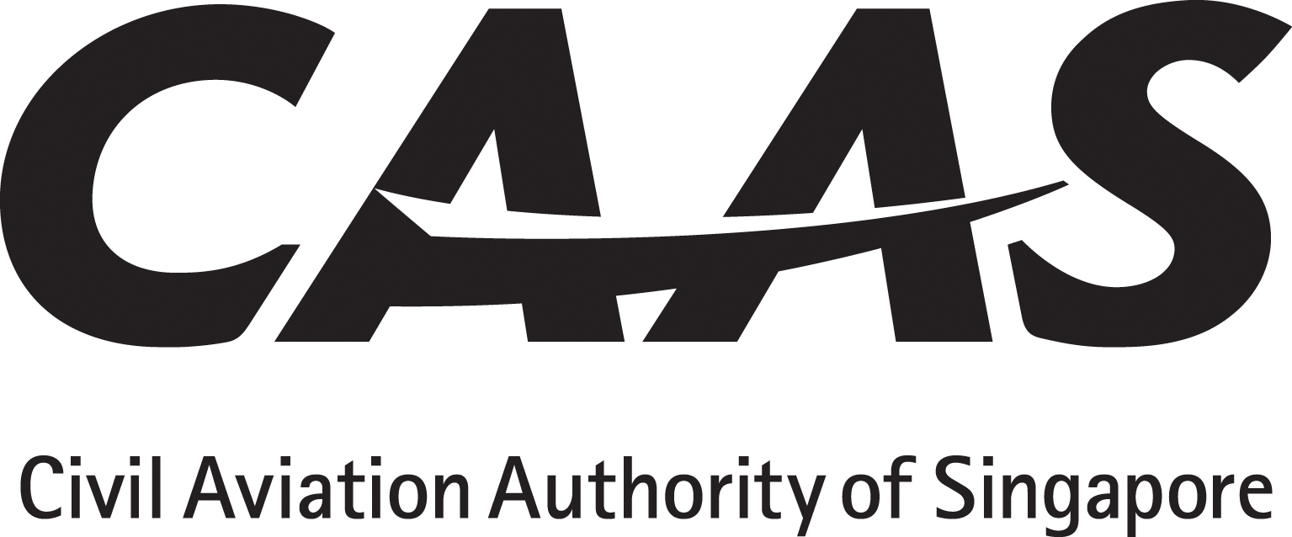
INSTRUCTIONS

1. The applicant will tick (√) the appropriate yes/no boxes and as applicable insert references from the AFM or Ops Manual with sample pages attached as appendix.
2. Applicant must obtain and submit manufacturer’s written confirmation with regard to continuing maintenance.
3. Operating policy and procedures, training syllabus and lesson plan must be submitted for approval before commencement of flight crew / dispatcher training.

PARTICULARS

Applicant:_______________________AOC No:__________ Rep’s name:_________________Position:______________

AWO APPLICATION DETAILS
1. GENERAL INFORMATION | DATA BY APPLICANT | CAAS USE
1.1 Applicant
1.2 Aeroplane Registration
1.3 Aeroplane Serial Number
1.4 Aeroplane Type / Model
1.5 Aeroplane Manufacturer

2 SCOPE OF APPLICATION |  | APPLICANT’S COMPLIANCE STATEMENT | CAAS USE
2.1 Apply for CAT II | □ yes □ no
2.2 Apply for CAT IIIA | □ yes □ no
2.3 Apply for CAT IIIB | □ yes □ no
2.4 Apply for LVP Take-off | □ yes □ no
2.5 Initial request for AWO Ops  approval for aeroplane type  in 1.4 | □ yes □ no
2.6 Others (please specify) | □ yes □ no
AIRWORTHINESS CERTIFICATION
1. CERTIFICATION DETAILS |  | DATA BY APPLICANT | CAAS USE
1.1 AWO Type Design Approval reflected in:
(a) AFM  (b) AFM Supplement  (c) TCDS  (d) STC  (e) Others (Please show evidence) |  | (a) □ yes □ no  (b) □ yes □ no  (c) □ yes □ no  (d) □ yes □ no  (e) □ yes □ no

1.2 AFM/TCDS/STC Airworthiness  approval for installed system:  (a) Category II  (b) Category IIIA  (c) Category IIIB |  | (a) □ yes □ no  (b) □ yes □ no  (c) □ yes □ no
1.3 System eligibility for referenced aeroplane serial number.
(a) Make____________________________________Model_______________________________TSO_______________________
(b) Make____________________________________Model_______________________________TSO_______________________
(c) Make____________________________________Model_______________________________TSO_______________________
(d) Make____________________________________Model_______________________________TSO_______________________
1.4 AWO type design approval reflected in:
□ Type design □ FAA STC □ EASA/JAA STC □ Service Bulletin □ CAAS STC □ Others: please specify.
 | AWO CONTINUING AIRWORTHINESS
 | SUPPLEMENT TO MAINTENANCE PROGRAMME
 | Maintenance Requirements |  | Data by applicant | Applicant’s compliance statement | CAAS Use
 | 1. An established Maintenance Programme containing all AWO maintenance requirements prescribed by the manufacturer or the design organization. |  | □ yes □ no
 | 2. The applicant must institute procedures in respect of continuing airworthiness practices for AWO. These procedures should cover the following subjects:  (a) Maintenance of AWO equipment (adherence to manufacturer’s instructions, modification procedures. Repair procedures, system calibration policy, AWO maintenance practices, handling of onboard systems etc.)  (b) Action for non-compliant aeroplane (downgrading, technical entries, corrective actions, placarding, upgrading, release to service procedures, monitoring and reporting of repetitive defects, reliability reporting, reporting to the Authority, etc.)  (c) Maintenance training (initial training and recurrent training of applicant’s maintenance management staff and contractor’s maintenance personnel, training syllabi, qualification of maintenance personnel, etc.)  (d) Test equipment (use of test equipment, handling, calibration, etc.) |  | □ yes □ no  □ yes □ no  □ yes □ no  □ yes □ no
AWO FLIGHT OPERATIONS
Operating Practices and Procedures |  |  | Data by applicant | Applicant’s Compliance Statement | CAAS Use
1. The applicant must institute AWO Operating Practices and Procedures. These practices and procedures should cover the following subject: |  |  |  | Reference to AWO Operating Practices and Procedures descriptions in Operations Manual: Chapter and paragraph
(a) Flight planning procedures, AWO status of aeroplane, review of Technical Log, use of MEL, external inspections, (navigation antennas, etc.);  (b) Requirements and normal procedures for CAT II/III approach flight profiles, crew coordination;  (c) Requirements and procedures for low visibility take-off;  (d) Requirements and procedures on the ground;  (e) Procedures with respect to flight crew response to abnormal situations (response to non-normal events, etc.);  (f) Post-flight procedures (Tech Log entries, defects and description, etc.);  (g) Continuous monitoring of low visibility operations. |  |  | □ yes □ no  □ yes □ no  □ yes □ no  □ yes □ no  □ yes □ no  □ yes □ no  □ yes □ no

Flight Crew Training and Qualification | Data by applicant | Applicant’s Compliance Statement | CAAS Use
1. Applicant’s Flight Crew Training syllabi. |  | Reference to descriptions in Operations Manual Part D: Chapter and paragraph
(h) Flight Crew Qualification Requirements;  (i) Description of initial and recurrent training. Checking and Training syllabi. | □ yes □ no  □ yes □ no
Warning: Notice is given that the operator shall accept full responsibility for all information given in this application form. Any attempt to provide false information will result in rejection of the application and, if already granted, the withdrawal of the Operational Approval. In addition, the operator may render himself liable to prosecution under section 29C(1)(b) of the Air Navigation Act.
I declare to the best of my knowledge and belief that the statements made and the information supplied in this form are complete and correct. I understand that any false representations made by me for the purpose of procuring the Singapore aviation safety instrument is an offence under section 29C(1)(b) of the Air Navigation Act and I may be subject to the penalties stipulated thereunder and any Singapore aviation safety instrument granted pursuant to the application will be revoked.

Signature / Name of person representing the applicant:_____________________________________Date__________________

Signature / Name of A/FO Officer accepting this form:_______________________________________Date_____ __________

REFERENCES
Regulatory: (1) ANR 98 PART 2 Division Regulations 4 – 9, Division 4, Regulations 20 - 33
Compliance: (1) CAAS AC 98-4-1 (0) (2) ICAO DOC 9365 (3) FAA AC 120-29A AC 120-28D (4) EASA CS - AWO

