APPLICATION FOR CPDLC / ADS-C
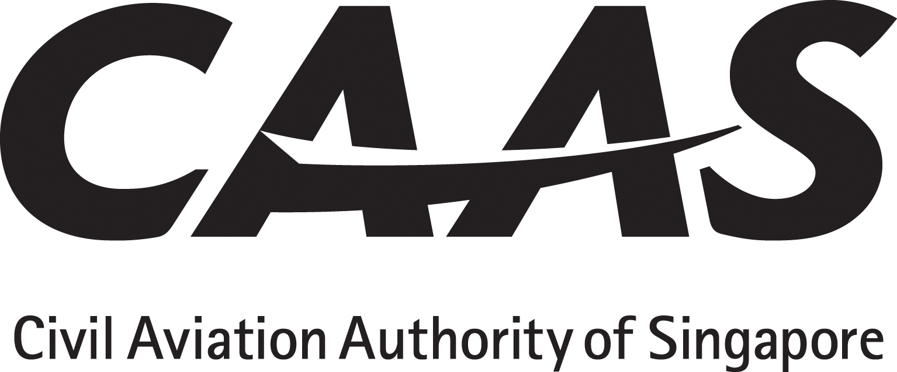
(Controller Pilot Data Link Communication / Automatic Dependent Surveillance-Contract)

INSTRUCTIONS
1. The applicant will tick (√) the appropriate yes/no boxes and as applicable insert references from the AFM or Ops Manual with sample pages attached as appendix.
2. The applicant must obtain and submit manufacturer’s written confirmation with regard to continuing maintenance.
3. Operating policy and procedures, training syllabus and lesson plan must be submitted for approval before commencement of flight crew / dispatcher training.

PARTICULARS

Operator: _______________________AOC No:________ Rep’s Name:________________________Position:______________
Aircraft manufacturer,  Model and series |  | Serial Number | Registration | Make & model of CPDLC / ADS-C | Area of operation requested
AC 98-6-1(Rev 0) | Title of Paragraph |  |  |  | Applicant’s Compliance Reference | CAAS Use
9  9.1 | AIRWORTHINESS REQUIREMENTS  Installation of data link equipage requires airworthiness certification. The operator needs to furnish to the Authority documents such as AFM entry or amendment to the aircraft TC or STC attesting to compliance with the standards set out in FAA AC 20-140().
10  10.1  10.2 | OPERATIONAL APPROVAL  While the primary guidelines for operational approval are provided by FAA AC 120-70(), in view that the worldwide operation of data link may not have been effectively harmonised, the operator shall develop his own operating policy/ procedures based specifically on the requirements of the areas / regions of his intended operations.  The operational approval by the Authority for CPDLC / ADS-C operation is worldwide and to ensure compliance with various regional requirements, the operator should refer to the following publications for guidance:  (a) Data Link Communication Operational Authorisation Information Package or equivalent;  (b) FANS Operations Manual (FOM);  (c) FAA Oceanic NOTAMS;  (d) FAA Pacific/Alaska Chart Supplements and North Atlantic Doc 007 or later versions;  (e) North Atlantic MNPS Airspace Operations Manual;  (f) ICAO Regional Supplement Doc 7030; and  (g) State Aeronautical Information Publications (AIPs).
10.3  10.3.1 | Submissions for Application  The following items are Authority requirements which must be submitted with the application letter:  (a) Evidence of compliance with airworthiness requirements;  (b) Equipment maintenance programme including training of personnel;  (c) Operating policy and procedures;  (d) Flight and dispatch crew training;  (e) MELs; and  (f) Other operational issues.
10.4  10.4.1  10.4.2  10.4.3  10.4.4 | Flight Crew Training  The operator shall submit its training programme for Authority approval.  Based on the operator’s operational experience and the limitations of the equipment or area of operation, the training can be ground based, computer based, or in a suitably equipped flight simulator.  For flight crew with no previous data-link experience, training through LOFT excises in a flight simulator is recommended.  For the syllabus contents, the operator’s training programme should be based on FANS-1/A Operations Manual (FOM) and should cover the following areas:  (a) Acronyms (FOM Part 2)  (b) General concept of digital and analogue communications  (c) Expected flight crew response  (d) ATS coordination  (e) Aircraft Communication components, displays, alerts (OEM document)  (f) Interface with other aircraft  (g) AFM information  (h) MEL provisions  (i) Data link event reports  (j) Data link malfunction or irregularity reports  (k) Human factor – lesson learned
10.5  10.5.1  10.5.2  10.5.3 | Grant of Operational Approval  The operator should take note of the Data Link Communication Operational Authorization Information Package (14 March 06) or equivalent.  At the Authority’s discretion, the operator may have to demonstrate adequacy of his training through Authority participation in his training sessions or line operations.  The Authority will write to the operator informing him of grant of the operational approval and the inclusion of CPDLC ADS-C in his Ops Spec.
CONTINUING AIRWORTHINESS
Maintenance practices
□Yes □No | MEL
□Yes □No | HMI Human / Machine Interface review.
□Yes □No | QSRA Qualitative Safety Risk Assessment

Warning: Notice is given that the operator shall accept full responsibility for all information given in this application form. Any attempt to provide false information will result in rejection of the application and, if already granted, the withdrawal of the Operational Approval. In addition, the operator may render himself liable to prosecution under section 29C(1)(b) of the Air Navigation Act.

I declare to the best of my knowledge and belief that the statements made and the information supplied in this form are complete and correct. I understand that any false representations made by me for the purpose of procuring the Singapore aviation safety instrument is an offence under section 29C(1)(b) of the Air Navigation Act and I may be subject to the penalties stipulated thereunder and any Singapore aviation safety instrument granted pursuant to the application will be revoked.

Signature / Name of person representing the operator:_____________________________________________Date__________________

Signature / Name of FS Officer accepting this form:_________________________________________________Date__________________

REFERENCES

Regulatory: (1) ANR-98, Division 6 – Data Link System, Regulations 34, 35 and 36.
Compliance: (1) AC 98-6-1(Rev 0) (2) FAA AC 20-140C Airworthiness Approval
Guidance: (1) ICAO Doc 10037 – Global Operational Data Link (GOLD) Manual
(2) Asia Pacific Operational Authorization Information Package – 15 Jun 2012

