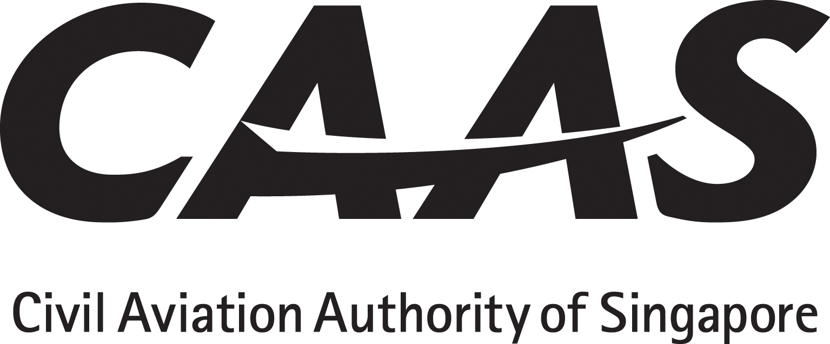
APPLICATION FOR AUTOMATIC DEPENDENT SURVEILLANCE – BROADCAST (ADS-B)

INSTRUCTIONS
1. The applicant will tick (√) the appropriate yes/no boxes and as applicable insert references from the AFM or Ops Manual with sample pages attached as appendix.
2. The applicant must obtain and submit manufacturer’s written confirmation with regard to continuing maintenance.
3. Operating policy and procedures, training syllabus and lesson plan must be submitted for approval before commencement of flight crew / dispatcher training.

PARTICULARS

Operator : ___________________________AOC No:___________ Rep’s Name:___________________Position:___________
Aircraft manufacturer, Model and series |  | Serial number | Registration | ABS-B Transmitter |  | GPS | S A Awareness / GPS (FDE)
AC 98-6-2(0) | Title of Paragraph |  |  |  | Applicant”s Compliance Reference |  |  | CAAS USE
8  8.1  8.2  (a)  (b)  (1)  (2)  8.3 | OPERATIONAL APPROVAL  The operation of ADS-B requires operational approval. The operator is required to submit to the Authority details of its equipage as per example below:  # Aircraft Type ADS-B Transmitter GPS S A aware / FDE functionality  1 B744 Honeywell TRA-67A Honeywell GLU-920 S A aware / GPS (FDE)  2 B777  3 A320  Additionally, the operator will submit to the Authority the following:  Evidence of approval by CASA or Airservices Australia; or  Statement of Compliance in accordance with:  EASA AMC 20-24; or  CASA AC 21-45  The ADS-B operational approval will remain valid until 31 December 2020 or on such date as determined by the Authority.
CONTINUING AIRWORTHINESS
Maintenance programme approval requirement
Maintenance practices
□Yes □No | MEL
□Yes □No | HMI Human / Machine Interface review.
□Yes □No | QSRA Qualitative Safety Risk Assessment

Warning: Notice is given that the operator shall accept full responsibility for all information given in this application form. Any attempt to provide false information will result in rejection of the application and, if already granted, the withdrawal of the Operational Approval. In addition, the operator may render himself liable to prosecution under section 29C(1)(b) of the Air Navigation Act.
I declare to the best of my knowledge and belief that the statements made and the information supplied in this form are complete and correct. I understand that any false representations made by me for the purpose of procuring the Singapore aviation safety instrument is an offence under section 29C(1)(b) of the Air Navigation Act and I may be subject to the penalties stipulated thereunder and any Singapore aviation safety instrument granted pursuant to the application will be revoked.

Signature / Name of person representing the operator:_____________________________________________Date__________________

Signature / Name of FS Officer accepting this form:_________________________________________________Date__________________

REFERENCES

Regulatory: (1) ANR-121, PART 2 Division 6 – Instrument and equipment, Regulations 126
Compliance: (1) AC 98-6-2(0)
(2) EASA AMC 20 – 24 (3) CASA AC 21 - 45

