APPLICATION FOR RNAV 10 / RNP 10
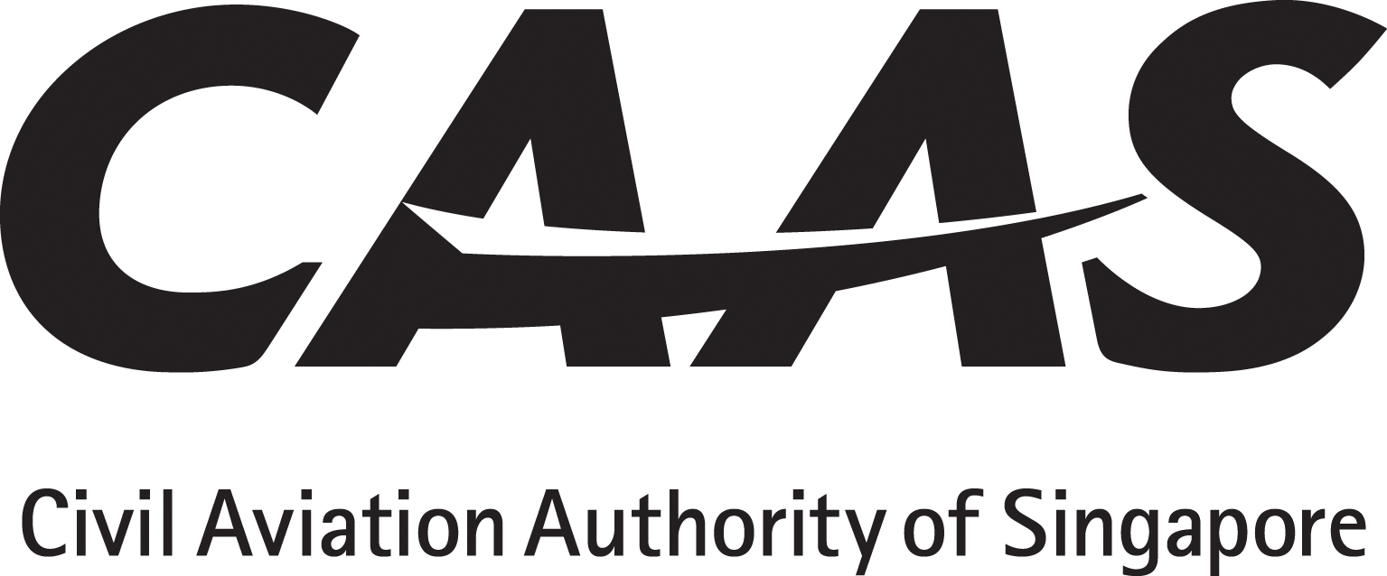
(AREA NAVIGATION 10 / REQUIRED NAVIGATION PERFORMANCE 10)
INSTRUCTIONS
1. The applicant will tick (√) the appropriate yes/no boxes and as applicable insert references from the AFM or Ops Manual with sample pages attached as appendix.
2. Operator must obtain and submit manufacturer’s written confirmation with regard to continuing maintenance.
3. Operating policy and procedures, training syllabus and lesson plan must be submitted for approval before commencement of flight crew / dispatcher training.
PARTICULARS
Operator : _________________________AOC No:___________ Rep’s Name:_________________Position:______________
Aircraft manufacturer,  Model and series |  | Serial number | Registration | No.of INS / IRS / IRU manufacturer and model | No. of GNSS manufacturer and model | No. of FMS / FMGC manufacturer and model |  | Any other Long Range Navigation systems and No. | RNAV/RNP specification
AC 98-2-2 | Title of Paragraph |  |  |  |  |  | Applicant’s Compliance Reference |  | CAAS Use
3 □yes □no  3.1 | Aircraft Eligibility  Aircraft meeting the following requirements (LRNS) are eligible for RNAV 10 operational approval:  (a) Dual INS or IRU approved in accordance with 14 CFR Part 121 Appendix G (Operating time limit with no radio-updating is 6.2 hour starting from engagement in inertial navigation mode.);  (b) Dual GNSS with FAA AC 20-138A certification for primary means of navigation in oceanic and remote areas subject to approved dispatch FDE prediction. (Maximum FDE outage time is 34 mins);  (c) Multisensor systems integrating GNSS with FDE approved using the guidance in AC 20-138( ), Appendix 1 can be considered to meet RNP 10 requirements without time limitations; or  (d) A combination of a single INS or IRU approved to 14 CFR Part 121 Appendix G standards, and a single GNSS approved in accordance with TSO-C196, TSO-C145 or TSO-C146.  Note: AFM documentation of compliance to FAA AC 90-105A Appendix G is one of the means to demonstrate RNP 10 capability.
□yes □no | CONTINUING AIRWORTHINESS  Maintenance programme reference
5 □yes □no  5.1  5.2  5.3 | FLIGHT OPERATIONS  Flight Crew Knowledge and Training  The operator must have programme to ensure the flight crew have the necessary knowledge and skills in RNAV 10 operations.  Where GNSS is used, the flight crew should be familiar with GNSS principles relating to air navigation.  The Authority may accept RNAV 10 training using ground-based instructional method.
Doc 9613  □yes □no | OPERATIONS MANUAL  Flight Planning  - Verify RNAV 10 time limit  - Verify requirement for GNSS, such as FDE, if appropriate.  Pre-flight procedures  - Review technical log  - Review emergency procedures  LRNSs fully serviceable and with integrity En route  Aircraft position X-check against Navaids for accuracy prior to entry  General operating procedures  Check time limit if operation with INS/IRU only. Time starts when system enters navigation mode and stops when reference to navaids.

□yes □no | MEL Minimum equipment list showing LRNS provisions
□yes □no | HMI Human / Machine Interface review.
□yes □no | QSRA Qualitative Safety Risk Assessment

“Warning: Notice is given that the operator shall accept full responsibility for all information given in this application form. Any attempt to provide false information will result in rejection of the application and, if already granted, the withdrawal of the Operational Approval. In addition, the operator may render himself liable to prosecution under section 29C(1)(b) of the Air Navigation Act.”
“I declare to the best of my knowledge and belief that the statements made and the information supplied in this form are complete and correct. I understand that any false representations made by me for the purpose of procuring the Singapore aviation safety instrument is an offence under section 29C(1)(b) of the Air Navigation Act and I may be subject to the penalties stipulated thereunder and any Singapore aviation safety instrument granted pursuant to the application will be revoked.”

Signature / Name of person representing the operator:____________________________________

Signature / Name of FS Officer accepting this form:_____________________________________

Revision History
Version | Date | Paragraph(s) | Details
1.0 | 01 October 2015 | Title & others | Miscellaneous
2.0 | 31 July 2019 | Various | Change in References

REFERENCES

Regulatory: (1) ANR-98
Compliance: (1) CAAS AC 98-2-2 (2) ICAO Doc 9613 (3) FAA Order 8400.12A

