APPLICATION FOR AREA NAVIGATION (RNAV) 5
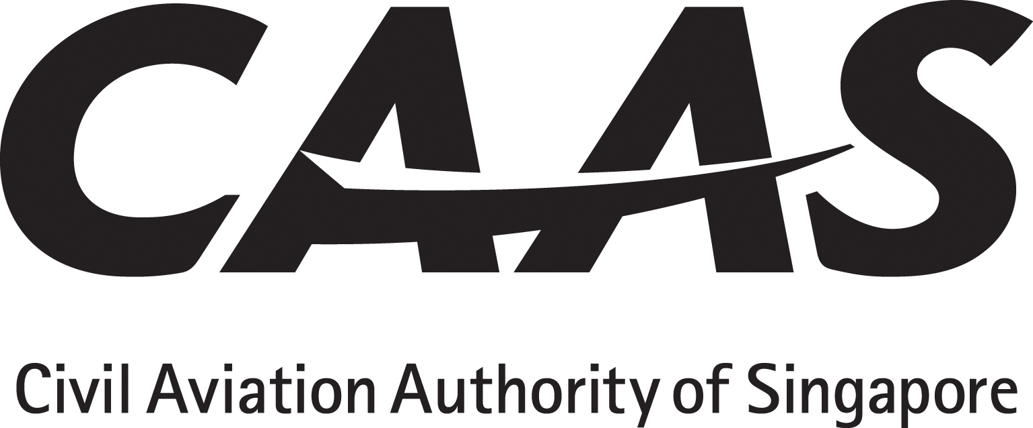

INSTRUCTIONS
1. The applicant will tick (√) the appropriate yes/no boxes and as applicable insert references from the AFM or Ops Manual with sample pages attached as appendix.
2. Operator must obtain and submit manufacturer’s written confirmation with regard to continuing maintenance.
3. Operating policy and procedures, training syllabus and lesson plan must be submitted for approval before commencement of flight crew / dispatcher training.

PARTICULARS

Operator : ________________________AOC No:___________ Rep’s Name:___________________Position:______________
Aircraft manufacturer,  Model and series |  | Serial number | Registration | No. of INS / IRS / IRU manufacturer and model | No. of GNSS manufacturer and model | No. of FMS / FMGC manufacturer and model |  | Any other Long Range Navigation systems and No. | RNAV/RNP specification
AC 98-2-3 | Title of Paragraph |  |  |  |  |  | Applicant’s Compliance Reference |  | CAAS Use
2 □yes □no | OPERATIONAL REQUIREMENTS  A summary of RNAV 5 requirements is as follows:  Only one RNAV system;  No navigation database is required waypoint data may be entered manually;  Minimum storage for 4 waypoints;  Alerting system is not required;  Navigation display in pilot’s FOV must be sufficient for track following and manoeuvring;  Maximum permitted cross-track error/deviation is 2.5 nm;  An indication for RNAV system failure is required.  With no automatic radio updating, the maximum operating time using INS or IRS is 2 hours. The limit time starts at navigation mode engagement.  GNSS certified under ETSO C129(A)/FAA TSO C129(A), or later, meets RNAV 5 requirements. Stand-alone ETSO C129/FAA TSO C129 GNSS receivers are acceptable provided they include pseudo-range step detection and health word checking functions. For GNSS-based operations, GNSS availability prediction is required for the route.
3  3.1 □yes □no  3.2 □yes □no | Aircraft Eligibility  Aircraft eligibility is determined through demonstration of compliance with the relevant airworthiness criteria promulgated in AMC 20-4 or FAA AC 90-96.  Aircraft with AFM, STC or manufacturer’s documentation, such as service letters, attesting to RNAV 5 airworthiness compliance are acceptable by the Authority.
□yes □no | CONTINUING AIRWORTHINESS  Maintenance programme reference
4 □yes □no  4.1  4.2  4.3 | OPERATING PROCEDURES  The operating procedures shall include and ensure the following:  The aircraft is serviceable for RNAV 5 operation:  Notation of RNAV 5 capability in the ATS flight Plan;  En-route loss of capability is identified and reported; and  Procedures for alternative navigation are described.  Manual entry of waypoint data in lieu of navigation database would increase potential for navigation error. To mitigate the human error potential, the operating procedures must include and conduct with diligence by the flight crew, systematic cross-check of entry waypoint data, track/distance/bearing against published charts for reasonableness.  As precaution, the operations should be conducted at or above minimum obstacle clearance altitude (MOCA) when validity of the navigation data cannot be assured.
DOC 9613  □yes □no | OPERATIONS MANUAL  Flight Planning  - Verify RNAV 5 Operational Approval.  - Confirm adequacy of normal and contingency procedures.  Pre-flight procedures  - Verify flight plan entry.  - Verify navdata for validity and currency  - Verify Navaid infrastructure and if GNSS fault detection (5minutes).  - In-flight procedures  - RAIM check  Contingency procedures.
5 □yes □no  5.1  5.2  5.3 | FLIGHT CREW KNOWLEDGE AND TRAINING  The operator must have programme to ensure the flight crew have the necessary knowledge and skills in RNAV 5 operations.  Where GNSS is used, the flight crew should be familiar with GNSS principles relating to air navigation.  The Authority may accept RNAV 5 training using ground-based instructional method.
□yes □no | MEL Minimum equipment list showing LRNS provisions
□yes □no | HMI Human / Machine Interface review.
□yes □no | QSRA Qualitative Safety Risk Assessment
“Warning: Notice is given that the operator shall accept full responsibility for all information given in this application form. Any attempt to provide false information will result in rejection of the application and, if already granted, the withdrawal of the Operational Approval. In addition, the operator may render himself liable to prosecution under section 29C(1)(b) of the Air Navigation Act.”
“I declare to the best of my knowledge and belief that the statements made and the information supplied in this form are complete and correct. I understand that any false representations made by me for the purpose of procuring the Singapore aviation safety instrument is an offence under section 29C(1)(b) of the Air Navigation Act and I may be subject to the penalties stipulated thereunder and any Singapore aviation safety instrument granted pursuant to the application will be revoked.”

Signature / Name of person representing the operator:____________________________________

Signature / Name of FS Officer accepting this form:_____________________________________

Revision History
Version | Date | Paragraph(s) | Details
1.0 | 01 October 2015 | Various | Minor editorial
2.0 | 31 July 2019 | Various | Changes in References

REFERENCES

Regulatory: (1) ANR-98
Compliance: (1) CAAS AC 98-2-3 (2) ICAO Doc 9613 (3) EASA AMC 20-4 (4) FAA AC 90-96A

