BAROMETRIC VERTICAL NAVIGATION (BAROVNAV) APPLICATION CHECKLIST
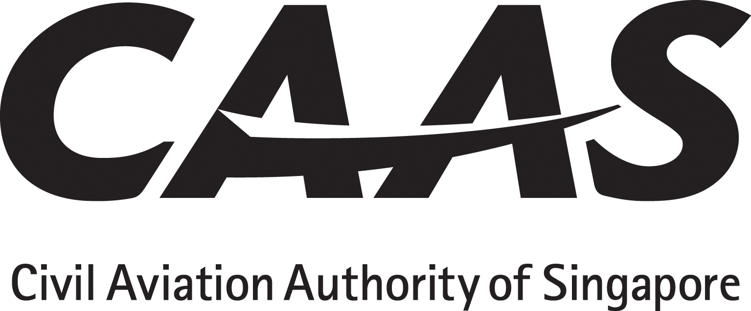
The applicant will tick (√) the appropriate yes / no boxes

DOCUMENTS TO BE SUBMITTED WITH LETTER OF APPLICATION
Description of Documents | Completion by Applicant | Remarks
1. Compliance statement which shows how the criteria of ANO Paragraph 13(2A) and AOCR Chapter 2 Paragraph 21 have been satisfied. | □ yes □ no
2. Sections of the AFM or AFM Supplement, TCDS Service Bulletin, Service Letter that confirms BaroVNAV or APV BaroVNAV eligibility. Alternatively written confirmation from aircraft or avionics manufacturer attesting to aircraft BaroVNAV eligibility. | □ yes □ no
3. Evidence of altimetry compliance with paragraph 10 of CAAS AC AOC 27(0) | □ yes □ no
4. Flight crew BaroVNAV or APV BaroVNAV training programme and syllabi for initial and recurrent training. | □ yes □ no
5. Operation manuals and checklists that include BaroVNAV or APV BaroVNAV operating practices / procedures:  - Operations Manual Part A,  - Operations Manual Part B,  - Operations Manual Part C  - Operations Manual Part D,  - FCOM, | □ yes □ no
6. Minimum Equipment List (MEL) that includes items pertinent to BaroVNAV operations. | □ yes □ no
7. Maintenance procedures, list of references of documents or programmes | □ yes □ no
8. Service Bulletin, Supplemental Type Certificate (STC) or Major Modification Approval Documentation, | □ yes □ no
9. Human / Machine / Interaction review | □ yes □ no
10. Quality System Risk Assessment | □ yes □ no

CAAS(FO)174
R1 10/15
Page 1 of 1

