Notes to applicant
General
- This form will take approximately 10 minutes to complete. Please complete the form ensure that the applicable fee is fully paid and all required supporting documentation is provided. Incomplete/incorrect form or/and inadequate payment will lead to delays in processing your application.
- Completed form and supporting documents are to be submitted to CAAS Flight Standards Division.

Fee
- The fee payable is prescribed in Paragraph 7 (4) of the Twelfth Schedule of the Air Navigation Order.
- Payment can be made via the following methods:

- Telegraphic/wire transfer to the following bank account:

Bank Name: DBS Bank Ltd
Bank Address: 12 Marina Boulevard, DBS Asia Central,
Marina Bay Financial Centre Tower 3, Singapore 018982
Account Name: Civil Aviation Authority of Singapore
Account No: 0039186673
Bank Code: 7171
Branch Code: 003
Swift Code: DBSSSGSG

- All bank charges and correspondent bank/agent fees, i.e., the remittance amount, your bank charges, as well as all the other banks’ (Intermediary and Beneficiary banks, etc.) shall be borne by the applicant and the Beneficiary receives full payment.
- Provide the necessary payment details, including your organisation name and purpose of payment (e.g., Renewal of User Approval) in your payment

- PayNow
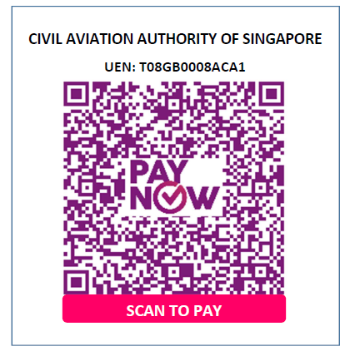
You do not need to submit this page with your application form.
Application Type (please tick ☑ as appropriate)
Initial Qualification of FSTD  Renewal of FSTD Qualification  Special Evaluation |  | Initial Issue of Approval to Use a FSTD  Renewal of Approval to Use a FSTD  Variation of Approval to Use a FSTD
Part A: Basic Particulars of Organisation
Name of Organisation:
Address of Organisation:

Name of Organisation’s Representative: |  |  | Designation:
Email: |  |  | Contact No:
Part B: FSTD Information
CAAS Certificate of Qualification No :
Date of issue (Qualification): |  |  | Date of expiry (Qualification):
Date of Entry Into Service: |  |  | Qualification Standard & Version (used at initial qualification):
Name of FSTD Operator (if different from Name of Organisation):
Address of FSTD Operator:
(if different from above)
Full Name of FSTD Manufacturer: |  |  | FSTD Manufacturer ID:
Location of FSTD
(if different from Operator’s):
Simulated Airplane Type & Variant: |  |  | Simulated Engine Model:
Engine Instrumentation: |  |  | Flight Instrumentation:
Visual System Model: |  |  | Motion System Model:
Level of Qualification (please tick ☑ as appropriate):
Type I Type II Type III Type IV Type V Type VI Type VII

Others, please specify (e.g. Grandfathered):
Name of Organisation(s) using the FSTD:

Part C: Application for Approval to Use the FSTD
(Not applicable if only applying for qualification of the FSTD)
- Expiry Date of Existing User Approval (If applicable):
- Date of Previous User Approval Evaluation (if applicable):
List all manuals which contain training programmes that will be conducted using the FSTD.
1. | ATO Training Manual:  Revision No.: / Date Approved:  ATO Training Manual:  Revision No.: / Date Approved:
2. | AOC Operations Manual ‘D’:  Revision No.: / Date Approved:
3. | AOC Flight Crew Technique/Training Manual(s):  Revision No.: / Date Approved:  AOC Flight Crew Technique/Training Manual(s):  Revision No.: / Date Approved:

Tick the applicable training tasks required for this FSTD and indicate the reference(s) in the manual.
MPL Training (Phase 2)  MPL Training (Phase 3)  MPL Training (Phase 4) |  |  | Reference:  Reference:  Reference:
Type Rating Training and Tests |  |  | Reference:
Instrument Rating Training and Tests |  |  | Reference:
Zero Flight Time Training |  |  | Reference:
Operator Proficiency Check |  |  | Reference:
Recurrent Training |  |  | Reference:
Recency Training (Take-off and Landing) |  |  | Reference:
Line Oriented Flight Training |  |  | Reference:
Special Authorisation(s):
Low Visibility Operations Training (LVO) |  |  | Reference:
Required Navigation Performance (RNP) Approach |  |  | Reference:
Required Navigation Performance with Authorisation Required (RNP AR)  Specify airport: |  |  | Reference:
ILS / Precision Runway Monitor (ILS / PRM) |  |  | Reference:
LDA / Precision Runway Monitor (LDA / PRM) |  |  | Reference:
Narrow Runway  Specify airport: |  |  | Reference:
Others, please specify: |  |  | Reference:  Reference:  Reference:

Part D – Applicant Checklist (Please check the applicable boxes)
For Qualification of the FSTD | Yes | No
Cover Letter
Compliance Statement of the FSTD
For Approval to Use the FSTD
Gap Analysis certified by the company. Date Submitted:
Part E – Applicant Declaration
I hereby declare that the information provided in this application and the accompanying documents are true in every respect.

_______________________________________ __________________________
Signature & Company Stamp Date (Day / Month / Year)

